**NITTE MEENAKSHI INSTITUTE OF TECHNOLOGY**

(AN AUTONOMOUS INSTITUTION, AFFILIATED TO VISVESVARAYA TECHNOLOGICAL UNIVERSITY, BELGAUM, APPROVED BY AICTE & GOVT.OF KARNATAKA

**Internship Report**

on

**WEM Modeler**

*Submitted in partial fulfilment of the requirement for the award of Degree of*

*Bachelor of Engineering*

*in*

*Computer Science and Engineering*

*Submitted by:*

|  |  |
| --- | --- |
| V VENKATA SREE HARSHA | 1NT18CS181 |



Department of Computer Science and Engineering

**(Accredited by NBA Tier-1)**

2021-22

**NITTE MEENAKSHI INSTITUTE OF TECHNOLOGY**

(AN AUTONOMOUS INSTITUTION, AFFILIATED TO VISVESVARAYA TECHNOLOGICAL UNIVERSITY, BELGAUM

, APPROVED BY AICTE & GOVT.OF KARNATAKA)

Department of Computer Science and Engineering

**(Accredited by NBA Tier-1)**

**CERTIFICATE**

This is to certify that the Internship Report on WEM Modeler is an authentic work carried out by V Venkata Sree Harsha **(1NT18CS181),** bonafide students of **Nitte Meenakshi Institute of Technology**, Bangalore in partial fulfilment for the award of the degree of ***Bachelor of Engineering*** in COMPUTER SCIENCE AND ENGINEERING of Visvesvaraya Technological University, Belagavi during the academic year ***2021-2022.*** It is certified that all corrections and suggestions indicated during the internal assessment has been incorporated in the report.

|  |  |  |  |
| --- | --- | --- | --- |
| **Signature of the HOD** | | **Signature of Principal** | |
|  | |  | |
| Dr. Saroja Devi  Professor, Head, Dept. CSE, NMIT Bangalore | | Dr. H. C. Nagaraj  Principal,  NMIT, Bangalore | |
| **Signature of Examiners** | | | |
|  | |  | |
|  | |  | |
|  | |  | |

**DECLARATION**

We are hereby declare that

(i) The Internship work is our original work

(ii) This Internship work has not been submitted for the award of any degree or examination at any other university/College/Institute.

(iii) This Internship Work does not contain other persons’ data, pictures, graphs or other information, unless specifically acknowledged as being sourced from other persons.

(iv) This Internship Work does not contain other persons’ writing, unless specifically acknowledged as being sourced from other researchers. Where other written sources have been quoted, then:

a) their words have been re-written but the general information attributed to them has been referenced;

b) where their exact words have been used, their writing has been placed inside quotation marks, and referenced.

(v) This Internship Work does not contain text, graphics or tables copied and pasted from the Internet, unless specifically acknowledged, and the source being detailed in the thesis and in the References sections.

|  |  |  |
| --- | --- | --- |
| **NAME** | **USN** | **Signature** |
| V VENKATA SREE HARSHA | 1NT18CS181 |  |

Date: 05/01/2022

**ACKNOWLEDGEMENT**

The satisfaction and euphoria that accompany the successful completion of any task would be incomplete without the mention of the people who made it possible, whose constant guidance and encouragement crowned our effort with success. I express my sincere gratitude to our Principal **Dr. H. C. Nagaraj**, Nitte Meenakshi Institute of Technology for providing facilities.

We wish to thank our HoD**, Dr. Saroja Devi** for the excellent environment created to further educational growth in our college. We also thank him for the invaluable guidance provided which has helped in the creation of a better project.

Thanks to our Departmental Project coordinators. We also thank all our friends, teaching and non-teaching staff at NMIT, Bangalore, for all the direct and indirect help provided in the completion of the project.

|  |  |  |
| --- | --- | --- |
| **NAME** | **USN** | **Signature** |
| V VENKATA SREE HARSHA | 1NT18CS181 |  |

Date: 05/01/2022

**Internship Certificate**

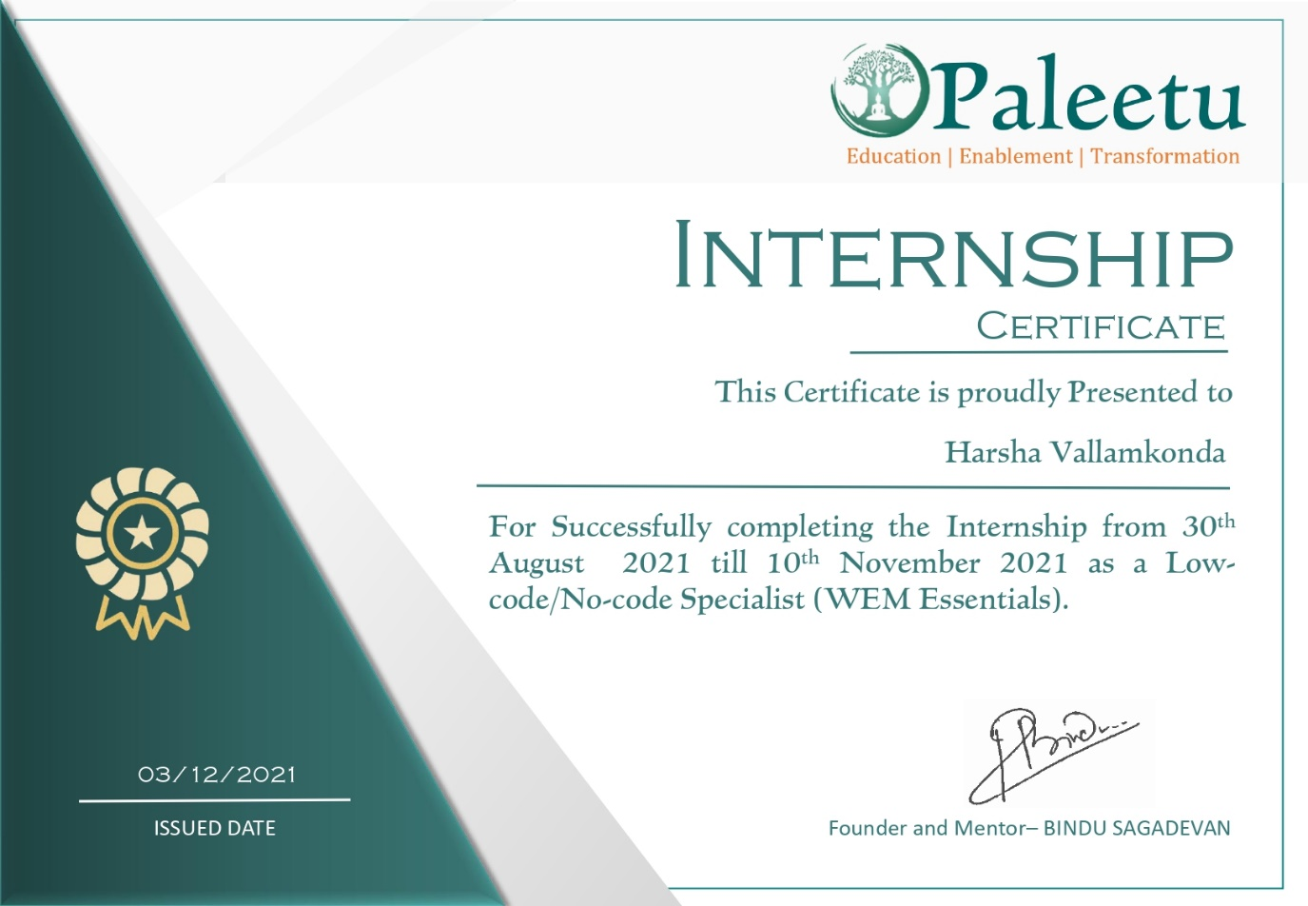

**Abstract**

Industrial training is an important phase of a student life. A well planned, properly executed and evaluated industrial training helps a lot in developing a professional attitude. It develops an awareness of industrial approach to problem solving, based on a broad understanding of process and mode of operation of organization. The aim and motivation of this industrial training is to receive discipline, skills, teamwork and technical knowledge through a proper training environment, which will help me, as a student in the field of computer science and engineering, to develop a responsiveness of the self-disciplinary nature of problems in information and communication technology. During a period of two months training at **Paleetu Educon and Enablement Services**, I was trained and assigned to develop applications using low code platform called WEM. As a result I vital to achieve the minimum requirement of the company, it will help the company to satisfy the overall architecture of the application in multiple projects and also the design phase of the application. Throughout this industrial training, I have been learned new platform that required for the system, the concept of the web development and able to implement what I have learnt for the past year as a bachelor of engineer in computer science and engineering student in Nitte Meenakshi Institute of Technology.

**Introduction**

* **Low-code Platform:** Low-code development platforms are types of visual software development environments that allow enterprise developers and citizen developers to drag and drop application components, connect them together and create mobile or web apps.
* These platforms are used in such a way that which can be developed the business level applications in a faster way.
* Low-code platforms are building sites that are just as impressive as ones built by skilled developers, and do it in less than half the time of their counterparts. The low-code web design movements are going through a renaissance.
* Low-code development's market growth can be attributed to its flexibility and ease. Low-code development platforms are shifting focus towards general purpose of applications, with the ability to add in custom code when needed or desired.
* Because they require less coding knowledge, nearly anyone in a software development environment can learn to use a low-code development platform. Features like drag and drop interfaces help users visualize and build the application.
* Some IT professionals question whether low-code development platforms are suitable for large-scale and mission-critical enterprise applications. Others have questioned whether these platforms actually make development cheaper or easier. Additionally, some CIOs have expressed concern that adopting low-code development platforms internally could lead to an increase in unsupported applications built by shadow IT.

**Background**

WEM: WEM Modeler is low code platform where we can develop applications with less code and in faster way. This WEM applications (or) Websites are fully secured and having good efficiency. Some of the features of WEM are:

* Built for security and scalability
* WEM Low-No code equals Incredible Speed & Flexibility
* Create documents, files, compute, automate, integrate
* Securely integrate with anything. Rapidly. Easily.
* Support for microservice architecture
* Create beautiful customer experiences
* Reduce Total Cost of Ownership
* Higher productivity
* Effective risk management and governance
* Improved agility. Operating at digital speed means creating the app capabilities users require to function smoothly across multiple devices.
* These low-code development platform market traces its origins back to 2011.

**Requirements Analysis**

The System requirements for the WEM Modeler as follows:

1. Laptop (or) PC (Minimum of 4GB RAM)
2. Good Wi-Fi Connection (10Mbps is decent)
3. Account in WEM
4. Having built in Debugger of HTML, CSS, Java Script.

**Implementation**

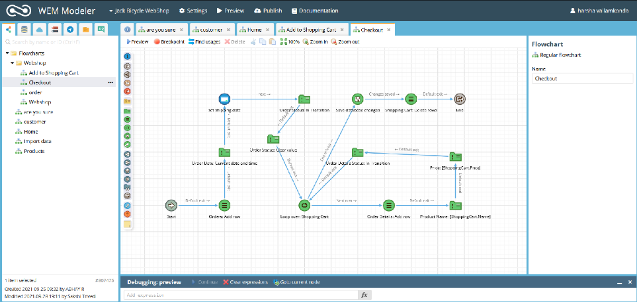

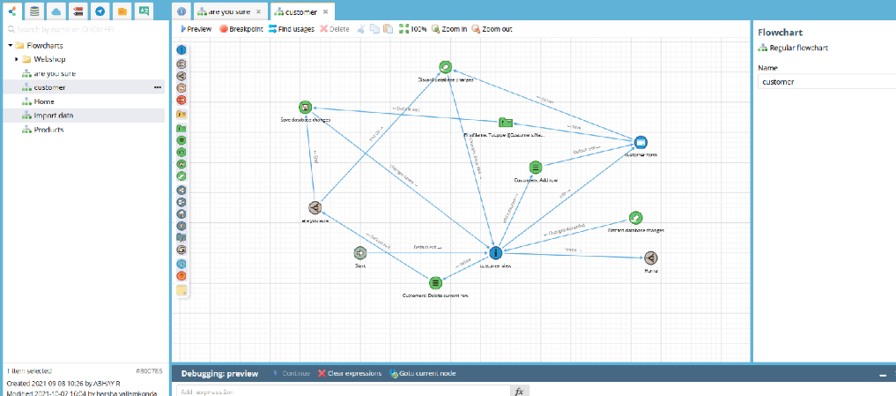

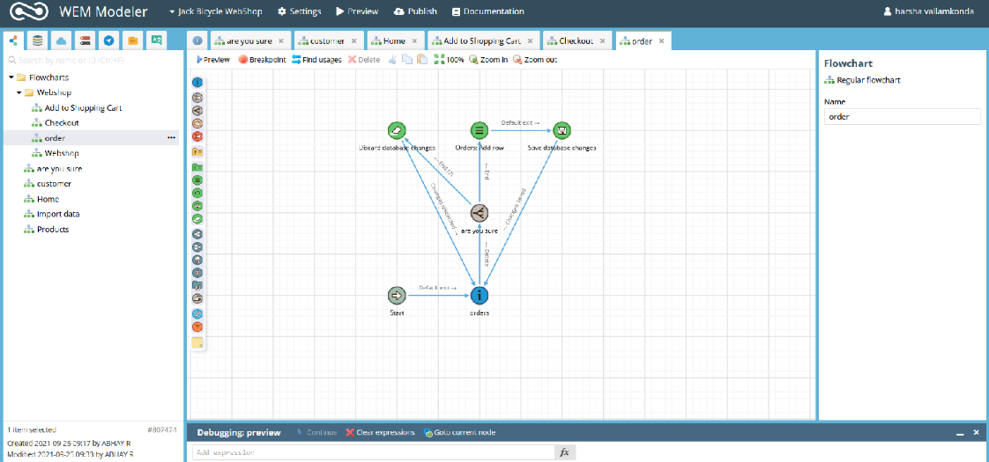

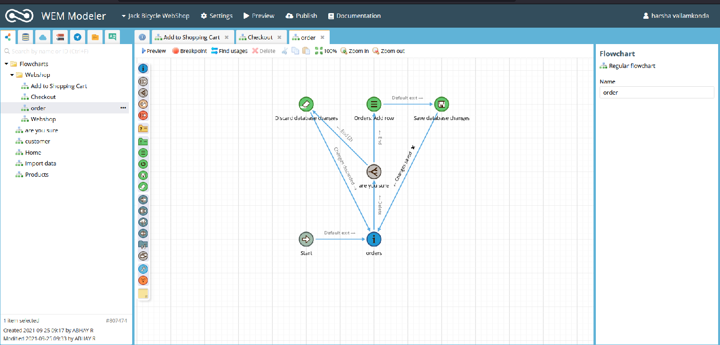

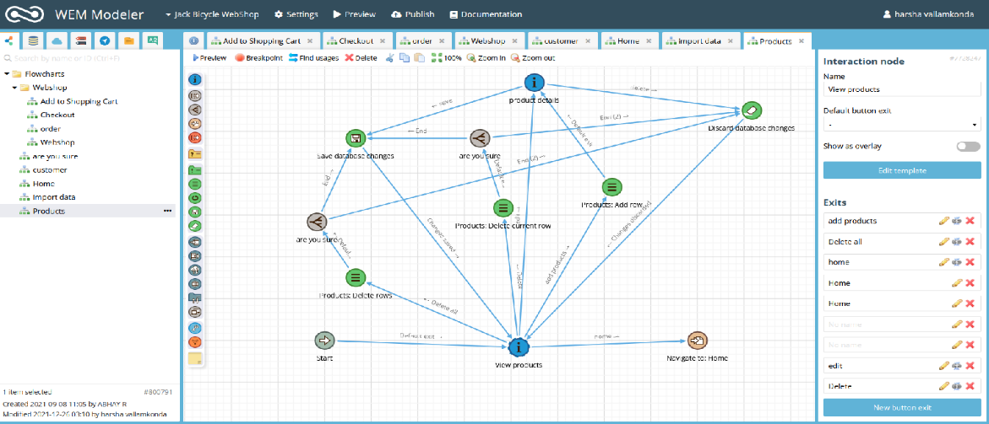

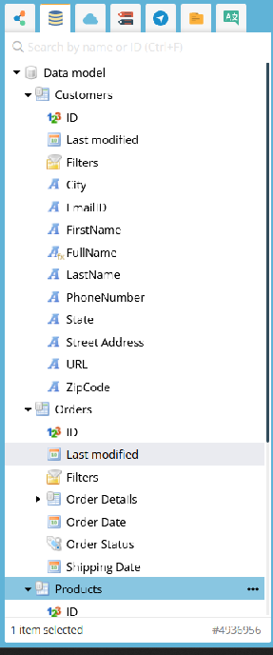 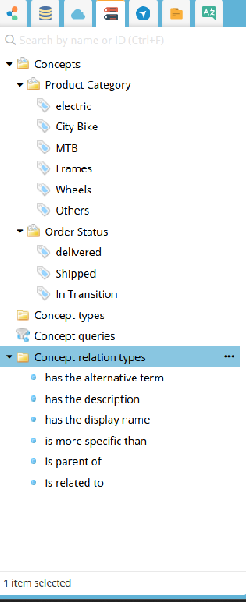 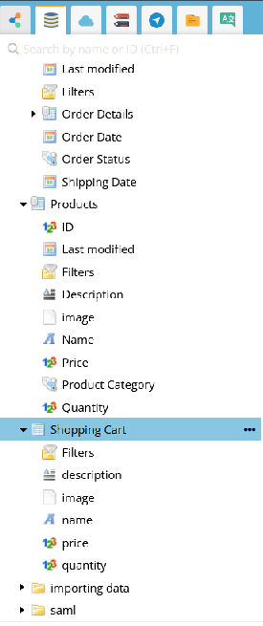

**Output**

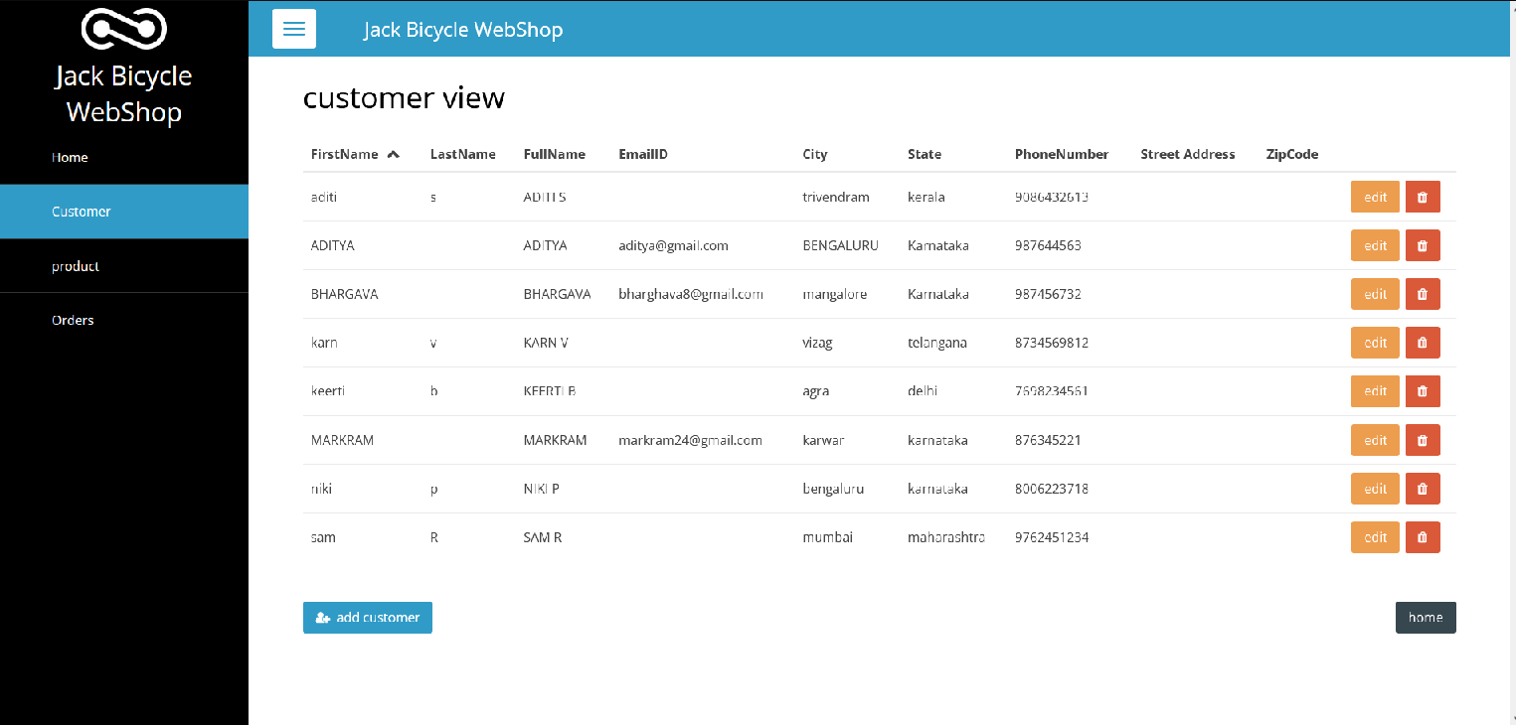

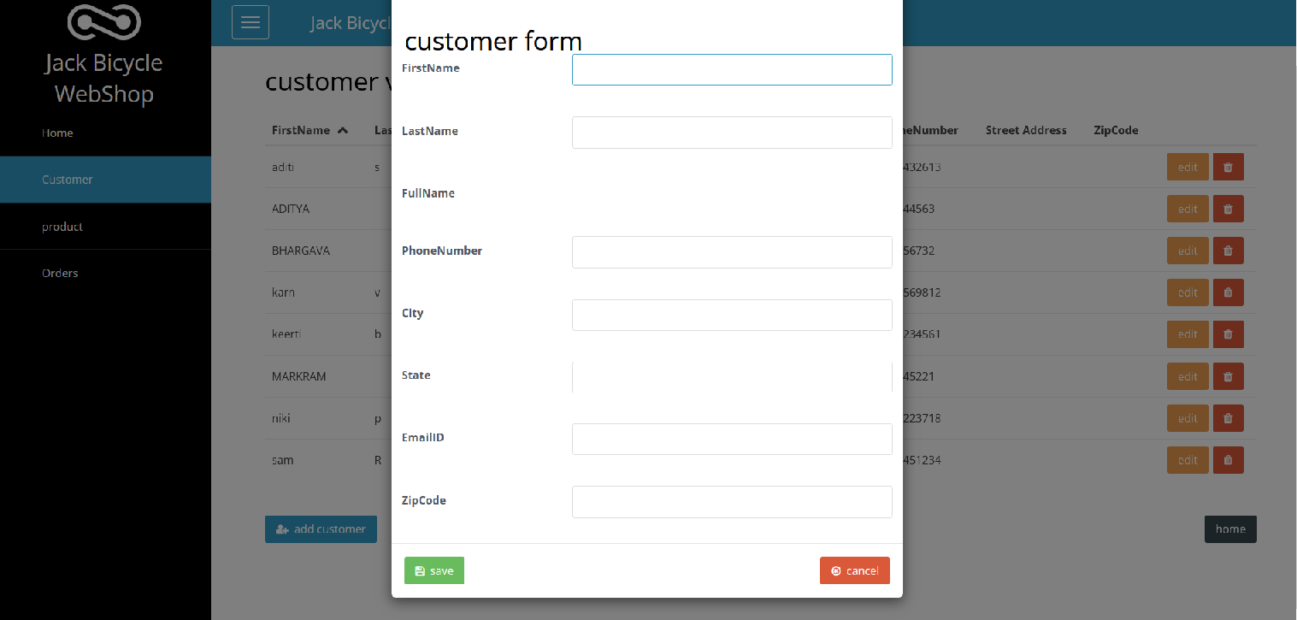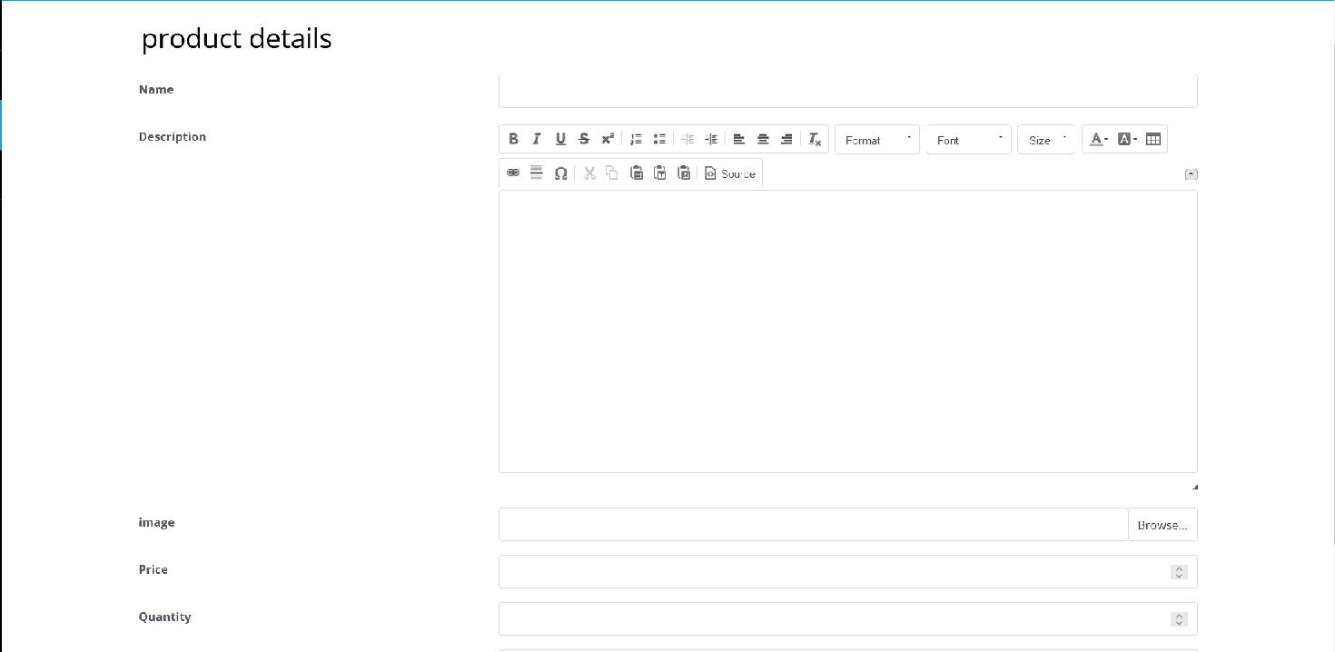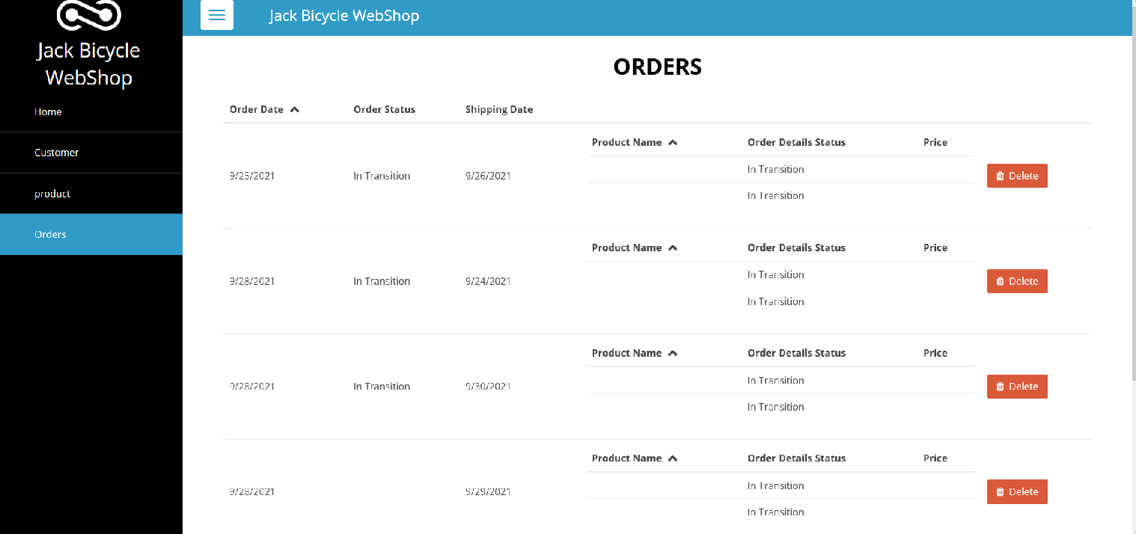

**Conclusion**

WEM allows us to develop RPA applications unlike any other platform. It gives us a very strong competitive edge in the market. WEM is powerful and reliable and we can rapid. And also with WEM we can develop applications with very less code and we can build applications at enterprise level. The processing and security everything will be handled by the WEM Modeler. Here in the above application we have done the logic and remaining server side part and flexibility of the application will be handled by WEM.

**References**

* [**https://www.google.com/url?sa=t&rct=j&q=&esrc=s&source=web&cd=&cad=rja&uact=8&ved=2ahUKEwiRi5i04__0AhUBheYKHaHHDCcQFnoECAYQAQ&url=https%3A%2F%2Fwww.creatio.com%2Fpage%2Flow-code&usg=AOvVaw2UWvpqAFtogPedPEG7ZaAD**](https://www.google.com/url?sa=t&rct=j&q=&esrc=s&source=web&cd=&cad=rja&uact=8&ved=2ahUKEwiRi5i04__0AhUBheYKHaHHDCcQFnoECAYQAQ&url=https%3A%2F%2Fwww.creatio.com%2Fpage%2Flow-code&usg=AOvVaw2UWvpqAFtogPedPEG7ZaAD)
* [**https://www.google.com/url?sa=t&rct=j&q=&esrc=s&source=web&cd=&cad=rja&uact=8&ved=2ahUKEwiRi5i04__0AhUBheYKHaHHDCcQFnoECGEQAw&url=https%3A%2F%2Fresearch.aimultiple.com%2Flow-code-statistics%2F&usg=AOvVaw3a5aus_8mv9rZHpieCjEaX**](https://www.google.com/url?sa=t&rct=j&q=&esrc=s&source=web&cd=&cad=rja&uact=8&ved=2ahUKEwiRi5i04__0AhUBheYKHaHHDCcQFnoECGEQAw&url=https%3A%2F%2Fresearch.aimultiple.com%2Flow-code-statistics%2F&usg=AOvVaw3a5aus_8mv9rZHpieCjEaX)
* [**https://wem.io/documentation/**](https://wem.io/documentation/)
* [**https://wem.io/**](https://wem.io/)
* [**https://whimsical.com/e-commerce-5CAL1x6H6kLRQUD4S8zmqj**](https://whimsical.com/e-commerce-5CAL1x6H6kLRQUD4S8zmqj)